[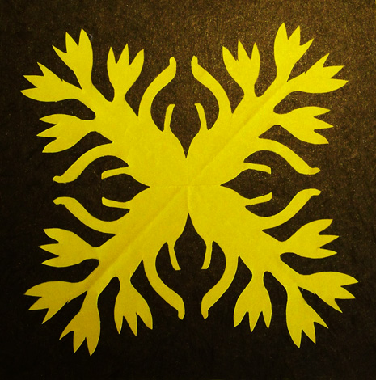](http://www.kid-at-art.com/htdoc/hawaiunit.html)